Sentiment Analysis

* Firstly, the dataset that 159254 tweets Data in which the tweets are divided into three classes that are positive, negative and neutral.
* We have applied the preprocessing of the dataset in which the data is cleaned.
* After the cleaning, we make vectors of the dataset for the input to the model.
* After vectorising the dataset we have splitted the dataset into 70% training and 30% test data.
* After separating the dataset, we need the dataset to send into the best model to check that which model is best for this dataset. We train four different models over this dataset and evaluate it over the test dataset.
* After the training of the model we get result in the form of accuracy scores, confusion matrix and classification reports.

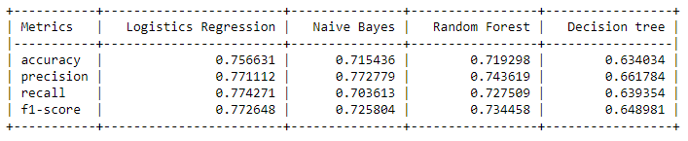

* From the results we can assumed that the Logistics Regression model is best for this model.